***Test plan***

**Tim Verhees**

*25-11-2022   
V0.2*

# **Versions**

|  |  |  |
| --- | --- | --- |
| **Date** | **Version** | **Description** |
| **04-11-2022** | 0.1 | Initial version |
| **25-11-2022** | 0.2 | Feedback processed |

# **Distribution list**

|  |  |  |  |
| --- | --- | --- | --- |
| **Date** | **Version** | **Name** | **Function** |
| **04-11-2022** | 0.1 | Tim Verhees | Project Handler |
|  |  | Maja | Technical Teacher |
|  |  | Jacco | Technical Teacher |
| **25-11-2022** | 0.2 | Tim Verhees | Project Handler |
|  |  | Maja | Technical Teacher |
|  |  | Jacco | Technical Teacher |

# **Test report**

Testing your application is important from several aspects. Namely Quality Assurance, Iterative Development and especially Agile Development. Testing your application helps you throughout the process to make sure everything works after making changes, so that the final version is a fully functional program. The are many ways to test an application and in this document I aim to outline which I use for my individual project.

Method

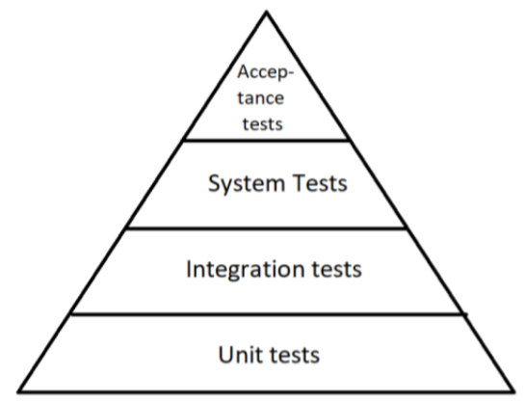The way I will test my application is through various forms of testing. This pyramid shows the type of tests I will be performing on my application to ensure the quality of the application.

Let’s start with the Unit tests; these are tests that will be found in the source code. They will test the various functions present in (predominantly) the back-end of the application. They test logic and will be run every time I push changes to the GitLab through a runner.

Now onto Integration tests; these test pertain to the combination of different modules. It tests the connection between different modules along the vertical scope of the application. In this case I will be testing the controller class in my back-end, seeing as this is the class that is directly responsible for the connection between the front- and back-end.

Third I will have System Tests; this kind of testing involves the Quality Assurance of the application and checks whether every button does what it’s supposed to do, all the correct data is being sent and received, etc... For this I will be using myself and an external program that runs through my application.

Lastly we have Acceptance Tests; these tests will be performed by the end-users of the application to see whether what I have made goes in line with their expectations. This will really show whether the website is able to handle human error and fits the user experience desired.